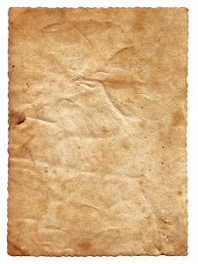
Name ~ Bertha Mason
Date of Birth ~3.4.1810
Spouse ~ Mr Rochester
Symptoms and Behaviours ~ Violent
~ Unreasonable temper
~ Shrieks incessantly
~Blank stare
~ Mood swings
~ Disturbing actions
Diagnosis ~ Delusional Irrationality
Signed ‘~ Doctor Charles

