Dear diary,
Today I was quietly reading on my favourite seat when that cruel cow john came looking for me. I had done nothing to disturb him but he believed that I had to be hurt. I hid behind the curtains, I took a glimpse of him and he was holding a sword. He walked straight past me and I heard Mrs Reed say hello to him. He walked back and I jumped on him and beat him many times. Carol and Sarah threw me into the red room, but I had done no wrong.
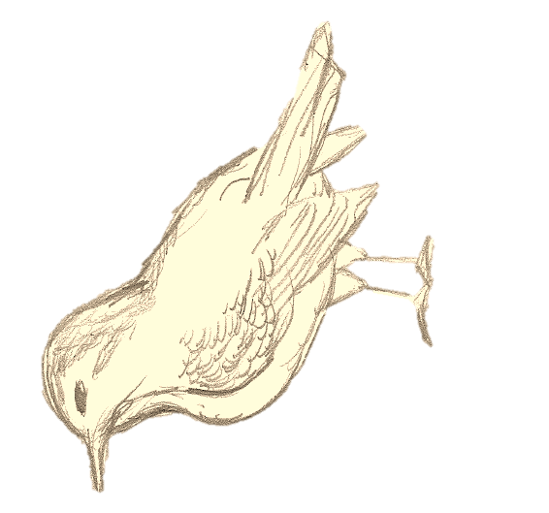
The red room sends chills down my spine; I hated it with passion like a deep poison in my blood. The red room was haunted and I knew it, they locked me in that room and I banged the door like an angry lion in a cage. I don’t remember much after that. My head is pounding. I hear Mrs Reed calling me I must go and answer her evil call.
I wish I was free, as free as a bird

Dear diary,
Today Mrs Reed called me to the drawing room. I was nervous as you never knew what she could say. She told me that I would be sent to Lowood, an institute for girls. The man was talking to Mrs Reed I didn’t know who he was and I was nervous to see where my future would be going.
Mrs Reed spoke about me like I wasn’t in the room. I hated her she was rude and cruel. She spoke of me like I was an evil child when I had done no wrong. They gave me some information about Lowood, it didn’t sound great but anything was better than this place. I guess my dream had come true it wasn’t perfect but it was enough for me. Mrs Reed thought that I deserved no affection but I am human and human needs attention and affection.
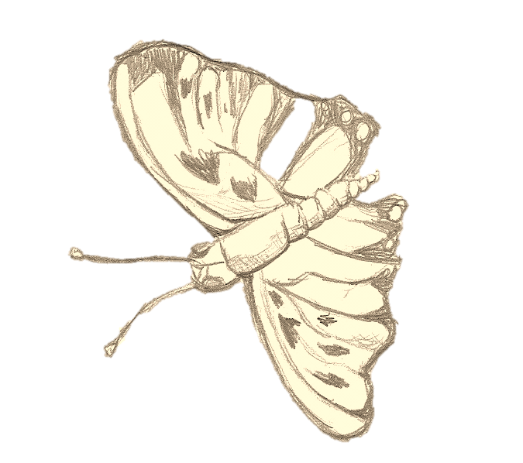
I hope that Mrs Reed doesn’t find my diary; it’s all I have to my name other than a few books and sketches. This is personal and I would hate for her to break into me even more than she has done. I saw a butterfly today it was beautiful and made me smile. It landed on my book and fluttered with such beauty. I wish people could appreciate me like I appreciate life

Dear diary,
It won’t be long now til I will take the horse and carriage to Lowood. I am nervous but I feel a great sense of relief to be free from Mrs Reed. I hope that when I arrive at Lowood I will find a friend who will show me affection. After all my years at Gateshead, I never received one word of love or praise or even just simple appreciation.
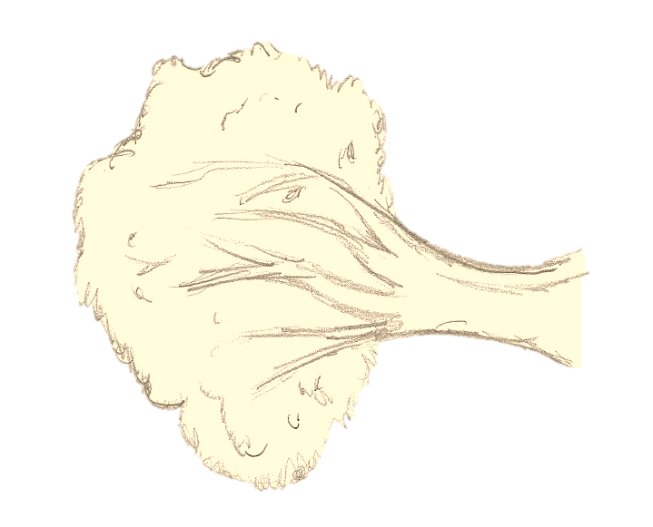
I hope that Lowood is better than here I need a change and I want to escape. John keeps teasing me saying that “I will be free from you” and laughing in that stinging laugh that he does. I hated him and I was glad to be free from his evil personality. I don’t know how he could treat me like this. He had a nasty soul; I can’t really blame him after having a mother like Mrs Reed.
Hopefully Lowood goes well.
Take Jane to Lowood

